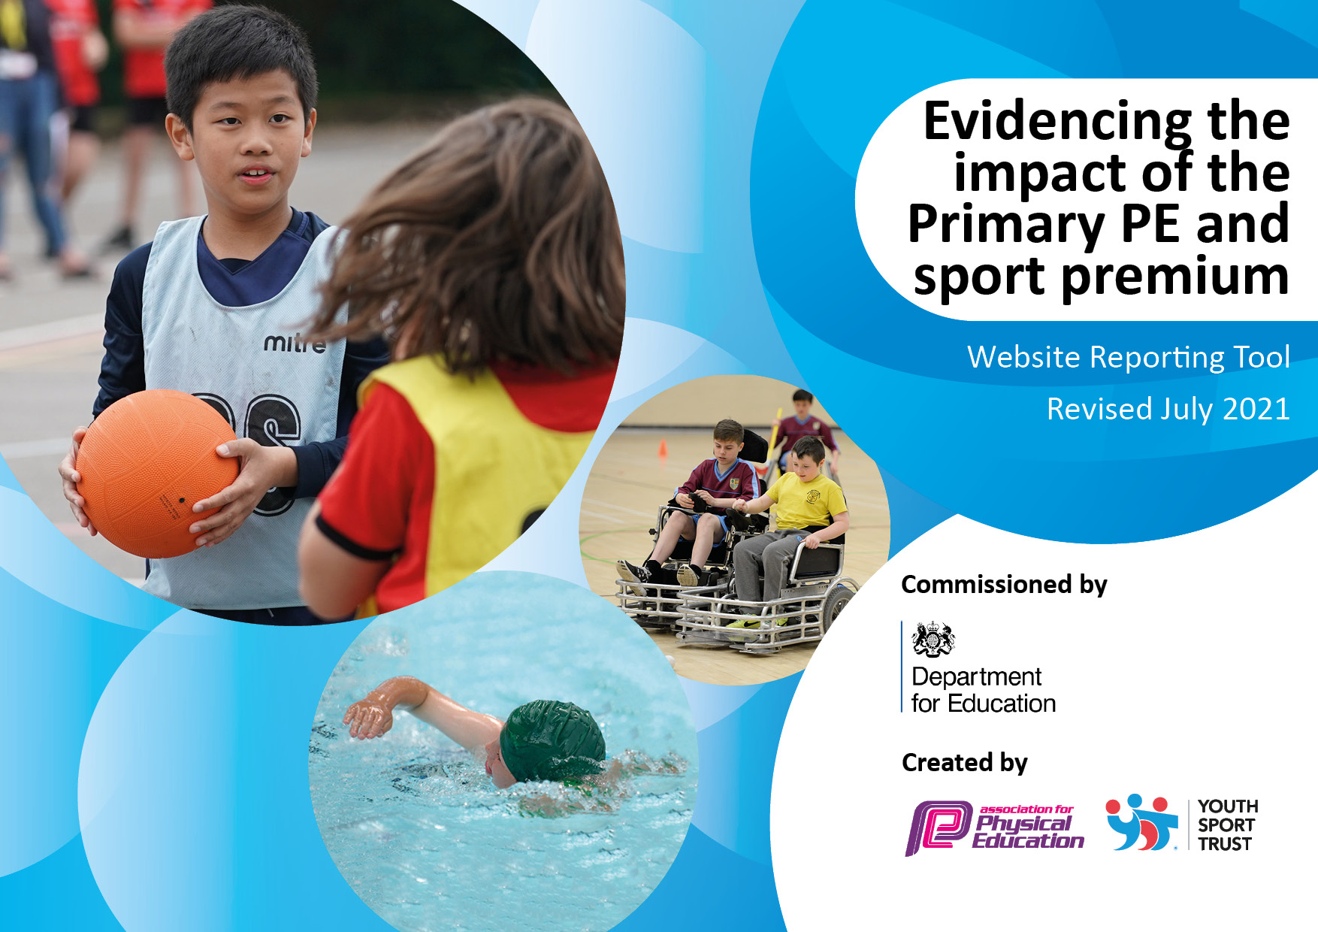
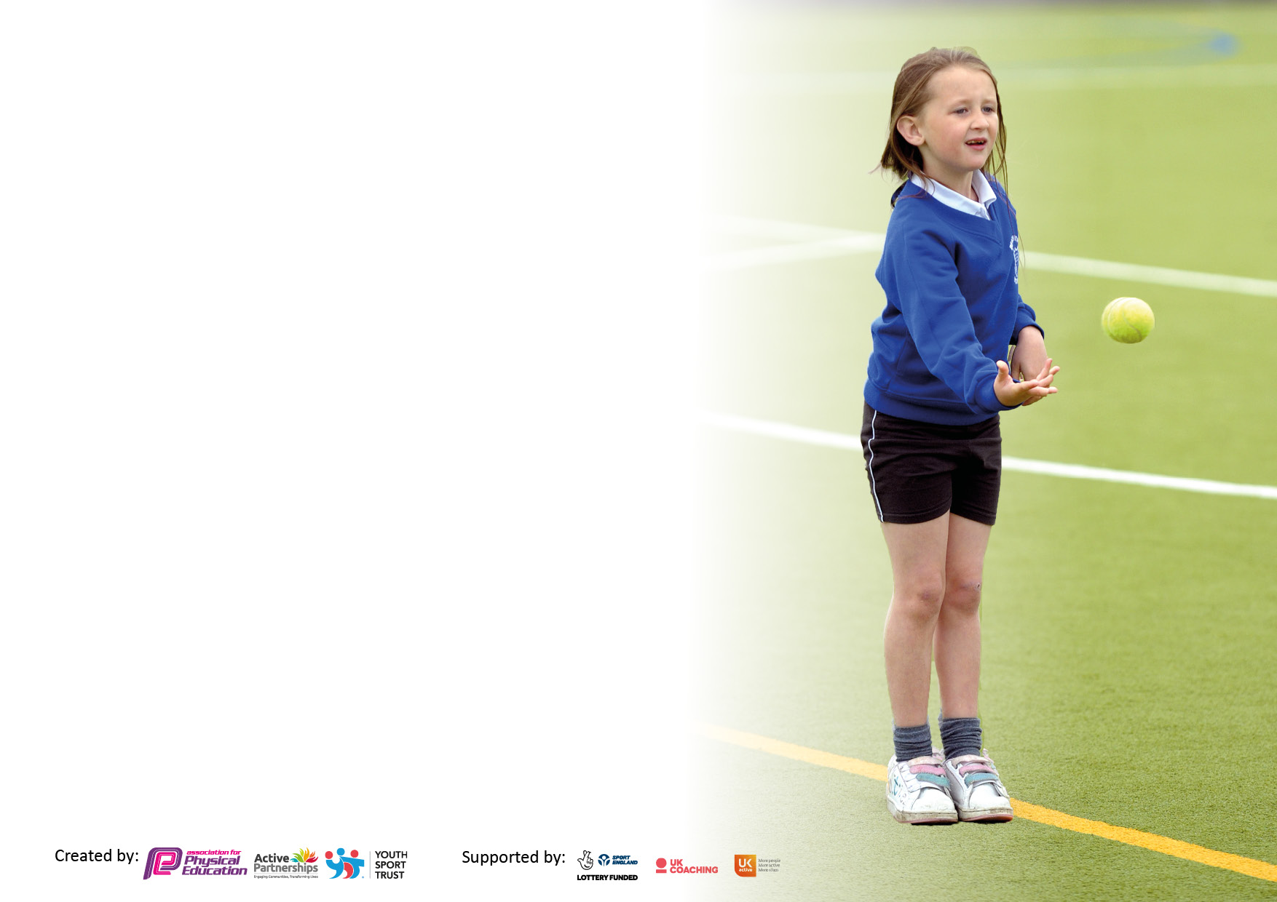

It is important that your grant is used effectively and based on school need. The Education Inspection Framework makes clear there will be a focus on ‘whether leaders and those responsible for governors all understand their respective roles and perform these in a way that enhances the effectiveness of the school’.

Under the Quality of Education Ofsted inspectors consider:
Intent - Curriculum design, coverage and appropriateness
Implementation - Curriculum delivery, Teaching (pedagogy) and Assessment
Impact - Attainment and progress

To assist schools with common transferable language this template has been developed to utilise the same three headings which should make your plans easily transferable between working documents.

Schools must use the funding to make additional and sustainable improvements to the quality of Physical Education, School Sport and Physical Activity (PESSPA) they offer. This means that you should use the Primary PE and sport premium to:

- Develop or add to the PESSPA activities that your school already offer
- Build capacity and capability within the school to ensure that improvements made now will benefit pupils joining the school in future years
- The Primary PE and sport premium should not be used to fund capital spend projects; the school’s budget should fund these.

Pleasevisitgov.ukfortherevisedDfEguidanceincludingthe5keyindicatorsacrosswhichschoolsshoulddemonstrate animprovement.Thisdocumentwillhelpyoutoreviewyourprovisionandtoreportyourspend.DfEencouragesschools to use this template as an effective way of meeting the reporting requirements of the Primary PE and sport premium.

We recommend you start by reflecting on the impact of current provision and reviewing the previous spend.

Schools are required to publish details of how they spend this funding, including any under-spend from 2019/2020, as well as on the impact it has on pupils’ PE and sport participation and attainment. All funding must be spent by 31st July 2022.

We recommend regularly updating the table and publishing it on your website throughout the year. This evidences your ongoing self-evaluation of how you are using the funding to secure maximum, sustainable impact. Final copy must be posted on your website by the end of the academic year and no later than the 31st July 2021. To see an example of how to complete the table please click HERE.
Created by: Supported by:

Details with regard to funding
Please complete the table below.

Total amount carried over from 2019/20 | £20,593.52
Total amount allocated for 2020/21 | £17,665
How much (if any) do you intend to carry over from this total fund into 2021/22? | £24,062.59
Total amount allocated for 2021/22 | £18,350
Total amount of funding for 2021/22. To be spent and reported on by 31st July 2022. | £42,412.59
Swimming Data
Please report on your Swimming Data below.

Meeting national curriculum requirements for swimming and water safety.

N.B. Complete this section to your best ability. For example you might have practised safe self-rescue techniques on dry land which you can then transfer to the pool when school swimming restarts.
Due to exceptional circumstances priority should be given to ensuring that pupils can perform safe self rescue even if they do not fully meet the first two requirements of the NC programme of study
What percentage of your current Year 6 cohort swim competently, confidently and proficiently over a distance of at least 25 metres?  N.B. Even though your pupils may swim in another year please report on their attainment on leaving primary school at the end of the summer term 2021.  Please see note above | 79%
What percentage of your current Year 6 cohort use a range of strokes effectively [for example, front crawl, backstroke and breaststroke]?  Please see note above | 74%
What percentage of your current Year 6 cohort perform safe self-rescue in different water-based situations? | 58%
Schools can choose to use the Primary PE and sport premium to provide additional provision for swimming but this must be for activity over and above the national curriculum requirements. Have you used it in this way? | Yes/No

Action Plan and Budget Tracking
Capture your intended annual spend against the 5 key indicators. Clarify the success criteria and evidence of impact that you intend to measure to evaluate for pupils today and for the future.

Academic Year: 2021/22 | Total fund allocated: £42,412.59 | Date Updated: 12.07.2022
Key indicator 1: The engagement of all pupils in regular physical activity – Chief Medical Officers guidelines recommend that primary school pupils undertake at least 30 minutes of physical activity a day in school |  |  |  | Percentage of total allocation:
%
Total fund allocated :
£42,412.59
Total Spent Overall:
£35,919.64 (This Year)
Total Spent in Indicator 1:
£20,468.51
Intent | Implementation |  | Impact
Your school focus should be clear what you want the pupils to know and be able to do and about  what they need to learn and to  consolidate through practice: | Make sure your actions to achieve are linked to your intentions: | Funding allocated: | Evidence of impact: what do pupils now know and what can they now do? What has changed?: | Sustainability and suggested next steps:
Renew subscription to ‘Maths of the day and Active English’ for Year 3 to Year 6. This is an active Maths and English program that can be used as a whole class, starter to a Maths/English lesson, to differentiate during main independent activity of Maths lesson or as an intervention program to plug gaps or be used to consolidate any misconceptions in pupil knowledge. using this regularly will raise the engagement of all pupils in regular physical activity.  Reactive Wall Subscription ActivAll helps to develop children’s multi-skills and coordination, whilst improving their overall health and wellbeing. Used to build confidence of SEND pupils and also to entice least active pupils to increase time physically active.  Play leader training for Year 6 pupils  Develop outdoor areas to ensure break times and lunchtime can facilitate high quality sporting and physical activity in a structured and organised manner, ultimately increasing the amount of time every child in the whole school engages in on a daily basis in physical activity. | - Subscription and resources to be repurchased  - Monitoring of class timetables to take place  - Creation of heatmaps  - Session drop ins to take place according to the monitoring and evaluation calendar  - Use to be monitored and tracked by class teachers, impact to be assessed  - Resubscription to ActivAll  - Reaction wall to be used as part of additional sensory diet for pupils with SEND needs and to be used as part of provision map for pupils identified as least active  - Impact to be monitored through selection of case studies.  - Identify group of children who want to participate in play leader training  - Children to be trained  - Children to be timetabled for leading session at break and lunchtime  - Buy suitable equipment for play leaders to be able to lead active session at break and lunch time  Meet with appropriate companies to design a bespoke plan for the development and redesign of outdoor areas in particular redesign of outdoor space including:  - A trim trail on the school playing field. This will be a multi activity trail use to increase the number of minutes all children are active daily  - Identify and meet with appropriate companies to design a bespoke plan for the fence activity boards.  - Once areas have been developed activities timetables to be created  - Intra school tournaments for lunchtime to reflect newly developed areas  - Break times and lunchtime to be timetabled.  - Staff to receive appropriate training.  - Regular drop ins to monitor impact according to the monitoring and evaluation calendar. | £487.50  Actual Spent:  £487.50  £3060.00  (Cancel Subscription)  Actual Spent  £3060.00  Training  FREE  Resources  £624.98  Actual Spent:  £150.41  Balance of the Trim Trail to be paid  £13,975.50  Actual Spent:  £16,770.60 | Heatmaps indicate the continued maintained impact that this additional active time has had on all pupils. The number of minutes on average every child has been active according to heatmaps has been maintained over above the national expectation.  -AM has conducted lesson drops ins to ensure the quality of the sessions delivered is high.  -Pupil voice conducted by AM indicates the continued positive impact that pupils have felt.  Cancel subscription (three year contract)  The reaction walls are no long in use.  Year 6 play leaders have fully enjoyed the responsibility and developed teamwork, communication and leadership skills throughout the year.  KQ- Observed lunchtimes and supported each child with leading games and activities. All children engaged and improved behaviour throughout lunch times.  Discussions with lunch time supervisors, very positive.  Pupil voice and feedback positive.  -Improved cognitive development.  -Develop core strength as well as balance and coordination.  -Provides exercise in a safe environment during playtime and lunch times.  -Builds self-esteem and confidence in the playground.  -SEND children use during sensory time. | Subscription to continue for next academic year. Build monitoring of sessions in monitoring and evaluation calendar.  Share good practice and where staff knowledge and confidence is high with other members of staff.  To continue next year with the name ‘Sports Leaders’ to offer further training so children can help with running clubs after school, PE lessons and sporting events eg. Sports Day, commonwealth day.  Communicate with the feeder high school, Hope Academy and invite their sports leaders in to work with our children to deliver a range of sporting activities.  To continue to gain training from the St. Helens sports development coach (DB) to train the next set of sports leaders.  -To continue to use during the school day.  -Complete pupil voice for impact.  -Monitor engagement.  -Include a case study linked to behaviour and improvement.
Key indicator 2: The profile of PESSPA being raised across the school as a tool for whole school improvement |  |  |  | Percentage of total allocation:
%
Total fund allocated :
£42,412.59
Total Spent Overall:
£35,919.64 (This Year)

Total Spent Indicator 2:
£2,375
Intent | Implementation |  | Impact
Your school focus should be clear what you want the pupils to know and be able to do and about  what they need to learn and to  consolidate through practice: | Make sure your actions to achieve are linked to your intentions: | Funding allocated: | Evidence of impact: what do pupils now know and what can they now do? What has changed?: | Sustainability and suggested next steps:
All children from Year 3- Year 6 to participate in a Circus Skills workshop. Dodger’s Circus Workshop aim to teach all children new physical skills and personal wellbeing. This is achieved through tried and tested sessions which are engaging, interactive, fun and memorable for all.  Quidditch games – and resources  Year 3-6  All children can develop their skills and knowledge of the game of Quidditch from the Quidditch tournament. | - Dodger’s Circus workshop booked and timetabled for Spring term.  - Children to blog about the impact and positive experience  - Collect evidence to show the impact and progress of mental health, wellbeing, behaviour and resilience  - To be implemented into the curriculum PE lessons.  - Preparation for intra and inter competitions.  - Staff training | £1,500  Actual Spent:  £1,500  875  Actual Spent :  £875 | -Circus workshop took place.  -All children participated in this event.  -Pupil feedback was very positive.  -Engagement was high.  -clear progression and development of a new skill.  -All children participated and engaged during lessons.  -Pupil feedback was very positive.  -Engagement was high.  -clear progression and development of a new skill. | To continue and develop new skills learnt.  To continue and develop new skills learnt.

Key indicator 3: Increased confidence, knowledge and skills of all staff in teaching PE and sport |  |  |  | Percentage of total allocation:
%
Total fund allocated :
£42,412.59
Total Spent Overall:
£35,919.64 (This Year)
Total Spent Indicator 3:
£395
Intent | Implementation |  | Impact
Your school focus should be clear | Make sure your actions to | Funding | Evidence of impact: what do | Sustainability and suggested
what you want the pupils to know | achieve are linked to your | allocated: | pupils now know and what | next steps:
and be able to do and about | intentions: |  | can they now do? What has
what they need to learn and to |  |  | changed?:
consolidate through practice:
In-order to improve the impact of progress and achievement of all pupils, key focus is to provide carefully identified, relevant and high quality CPD to upskill staff to ensure quality first teaching and coaching for all pupils across the school during curriculum and extra-curricular activities.  Provide renewal of planning resources for all teaching staff to ensure high quality first PE curriculum sessions and extra-curricular activities. Use to build confidence of SEND pupils who need a sensory diet. | - Cricket specialist coaching delivered through Lancashire Cricket Club throughout the academic year for Years 3-6  - During this time, class teachers and LSA will be provided with high quality CPD that is bespoke to the individual needs of the children.  - Termly drop in sessions will take place to ensure the impact of this CPD can be seen, to ensure value for money, impact and sustainability over time  - High quality weekly observations and termly assessments of pupil’s progress and attainment to be made to ensure impact on all pupils individually  - Purchase renewal of high quality planning resources  - Planning and session drop-ins monitoring to take place according to the monitoring and evaluation calendar  - Assessment system to be developed further to ensure that any gaps in pupils skills can be identified and that impact and progress can clearly be seen for all individual pupils and groups of children.  - SENsory skills feature to be used as part of additional sensory diet for pupils with SEND needs | £699.00  Actual Spent:  £699.00  Last Budget Year.  £395  Actual Spent:  £395 | Specialist coaching delivered across a variety of year groups. Year 3 and 5 participated in cricket lessons. Feedback from parents was exceptionally positive.  -In year groups where this has taken place significant impact has been seen, staff have continued to gain a better understanding of the strategies needed to deliver high quality cricket lessons and afterschool clubs.  -Children have received high quality provision that has had a significant impact.  -number of children who have been signposted to local clubs has increased. The highest ever figure of children attended All Stars at our local cricket club.  -number of children playing competitive cricket and representing local cricket teams has maintained at a high standard.  -Pupil voice conducted by KQ showed significant impact  -Sample of Staff questionnaires also showed significant impact and positive  -Throughout the year, a number of curriculum development and evaluation meeting have taken place, the planning resources have provided support and clarity to the ongoing curriculum development ensuring that the curriculum and wider pe and sport provision is of a high standard and is challenging for all groups of learners.  Teaching staff and teaching assistants have continued access to high quality skills based progression planning. The quality of extracurricular clubs and sessions delivered by our staff have continued to be improved significantly due to additional planning resources, due to this pupils have assessed high quality free extra-curricular club at both dinner and lunchtime across the year. | Strategy will be included in next academic year. Sustainability to continue to provide high quality CPD for staff, increasing their knowledge, confidence and skills.  Continue with monitoring activities, pupil voice, monitoring engagement levels, monitoring and tracking progress and impact.  Continue with Strategies. Look to develop the use of SENsory Skills feature and how this can be used to support children with SEND.  Monitor impact, include case studies. Conduct pupil voice.  Ask staff to complete a skills audit.
Key indicator 4: Broader experience of a range of sports and activities offered to all pupils |  |  |  | Percentage of total allocation:
Total fund allocated :
£42,412.59
Total Spent Overall:
£35,919.64 (This Year)
Total Spent Indicator 4:
£4,849
Intent | Implementation |  | Impact
Your school focus should be clear | Make sure your actions to | Funding | Evidence of impact: what do | Sustainability and suggested
what you want the pupils to know | achieve are linked to your | allocated: | pupils now know and what | next steps:
and be able to do and about | intentions: |  | can they now do? What has
what they need to learn and to |  |  | changed?:
consolidate through practice:
Additional achievements:  Expand the existing orienteering course on the Junior school grounds that can be used by all pupils. Orienteering development will ensure we continue to provide another dimension to the sporting provision provided at St Mary’s and will meet the needs of more reluctant sport engaging pupils focusing upon the ‘fun engagement within the outdoor environment’ will be perfect to engage SEND pupils who will feel confident within their familiar environment whilst making cross curricular links.  Extra-curricular clubs to be run at lunchtimes and afterschool available to all children, providing a variety of different sports and activities  Purchase additional resources to facilities free after and extracurricular activities.  Staff to run and facilitate free extra-curricular clubs at lunchtime and after school available to all pupils.  Short Golf Teaching kit  Forest schools sessions – Half termly Forest Schools sessions to be offered to each class from Year 3 – Year 6 | - Work with ‘Enrich’ to design an addition to our existing tailor made course appropriate and engaging for all pupils.  - All staff to receive refresher training resources.  - All teachers to deliver at least 1 session per half-term to their class.  - Drop in session to monitor impact and progress according to monitor calendar.  - Subscribe for the year to Enrich’s Education School Orienteering and Outdoor Learning Hub  - Provision map to be created  - Resources purchased to ensure a rich and balanced variety of extra-curricular club delivered free of charge to all pupils.  - Assessment to take place to ensure specific groups of children are targeted to attend.  - Target that all children are invited and attend at least 1 after school club.  - Sessions to take place  - Attendance to be mapped  - Heatmaps to be created  - Impact case studies written to show impact and effect  - To be implemented into the curriculum PE lessons.  - Preparation for intra and inter competitions.  - Staff training  - Provision map to be created  - Sessions to be mapped with cross curricular areas  - Resources and instructor to be paid for from a highly recommended company – Kabs  - Impact to be monitored | £500.00  (NIL)  Learning Hub - FREE for 1 Year  £1,990  Archery set  Actual Spent:  £1724  £1500  Actual Spent:  £1475  £6000  Actual Spent:  £1650 | To be achieved next academic year 2022/23  To be achieved next academic year 2022/23  -child-centred learning process that allows children to explore, discover through play and gives pupils the opportunity to take risks in a nurturing environment.  - Learning outdoors and in a new environment gives children a new stimulus to learn.  Cross -curricular links with History and Geography lessons. | NA  Strategy will be included in next academic year. Sustainability to continue to provide high quality CPD for staff, increasing their knowledge, confidence and skills of teaching forest school.  Continue with monitoring activities, pupil voice, monitoring engagement levels, monitoring and tracking progress and impact.

Key indicator 5: Increased participation in competitive sport |  |  |  | Percentage of total allocation:
%
Total fund allocated :
£42,412.59
Total Spent Overall:
£35,919.64 (This Year)
Total Spent Indicator 5:
£7,832.13
Intent | Implementation |  | Impact
Your school focus should be clear | Make sure your actions to | Funding | Evidence of impact: what do | Sustainability and suggested
what you want the pupils to know | achieve are linked to your | allocated: | pupils now know and what | next steps:
and be able to do and about | intentions: |  | can they now do? What has
what they need to learn and to |  |  | changed?:
consolidate through practice:
To continue to promote and introduce additional competitive sports in and outside of school.  To increase % based upon last academic year, the number of children who participate in intra and inter competitions.  Annual Whole school ‘Quidditch’ intra-school competition. This will ensure that every single child in the school across both sites will participate in at least one intra school competition during the academic year.  Improve the quality of the Gym provision/resources to ensure we have high quality resources to be able to compete at competition level  Purchase sporting achievement award to be given out during celebration/ sporting intra school tournaments.  Spanish Day-Dance Days-flamenco for all children to participate in cross-curricular learning. | - Create academic year sports provision map.  - Arrange friendly local sport competitions with other local schools.  - Enter a range of inter-competitions on a termly basis  - Map pupil profile entries and participation  - Purchase Gold School Games service level agreement  - Pay for transport to access additional sports competitions  - Work with the company ‘Enrich’ to develop a 5th Annual school Quidditch intra school tournament.  - Celebration event to celebrate success and participation of all pupils.  - Participate in inter-school tournaments with other schools locally and regionally.  - Installation of high quality gym equipment in the hall to ensure we can run high quality after school gym session aimed at the target group of children who are exceeding the expected standard in Gymnastics.  - Purchase of higher specification resources will enable us to develop the skillset of these children further  - Children to be entered into advanced tournament/competitions.  - Awards to be purchased and give out at times linked with the provision map.  - Spanish workshop booked and timetabled for summer term.  - Children to blog about the impact and positive experience  - Collect evidence to show the impact and progress of mental health, wellbeing, behaviour and resilience. | SLA-£950  Actual Spent:  £749  Transport-  £3000  Actual Spent:  £1640  £875  Actual Spent:  £990  £5000  Actual Spent:  £3,819.89  £100  Actual Spent:  £248.24  £400  Actual Spent  £385 | In school we held a number of intra tournaments, as a whole school, year groups and class.  These included football, multi-skills,  Pupil feedback was very positive, children enjoy the opportunity to compete in competitive sport they take pride in representing their class, year group and school. Children are confident In verbalising our PE and Sport charter value.  -Annual Quidditch Event was held as a lower school event due to covid.  -Pupil feedback was exceptionally positive.  -Target ed engagement in least active pupils was yet again high.  -Clear progression of skills in Y4 build upon from previous competition.  Due to work taking place in the hall and issues with supply. This work did not take place.  Money spent on gymnastics resources.  Promoting teamwork, leadership and communication skills.  Encouraging participation within sports.  Rewards and prizes (Sports Day, Common Wealth day, sports week)  -All children participated in this event.  -Cross-curricular learning  -Dance  -Engagement was high  -Children development new skills  -Well-being promoted throughout the day. | Continue with higher tier SLA. Continue to use My School Games Tracker to log intra and inter tournaments. Continue to develop the use of whole school celebration of PE and Sports Events like our summer festival.  Continue to strategy with Annual Quidditch tournament this is to be an extended 2 day event and will launch house captains and houses at the beginning of the Autumn Term 22-23.  Resources to be purchased, once installed. Map impact of spending through heat map identification, pupil voice, assessment of skills, staff CPD.  Booked next year for the whole school.

Signed off by
Head Teacher: | John Daley
Date: | 24th July 2022
Subject Leader: | Kayleigh Quirk
Date: | 19.07.22
Governor: | Vanessa Wells
Date: | 24th July 2022

